## 1)Python program to demonstrate math functions

import math

fact_value=math.sqrt(16)

print("Square root of 16 is %i "%fact_value)

exp_value=math.exp(0.5)

print("Exponential value is %f "%exp_value)

abs_value=math.fabs(-4)

print("Absolute value of -4 is %i "%abs_value)

factt_value=math.factorial(4)

print("Factorial of 4 is %i "%fact_value)

ceil_value=math.ceil(4.35)

print("ceil value of 4.35 is %i "%ceil_value)

log_base2=math.log2(5.2345)

print("The natural log of 5.2345 is %f "%log_base2)

log_base10=math.log10(5.2345)

print("The logarithmic value of 5.2345 to the base 10 is %f "%log_base10)

gcd_value=math.gcd(6,69)

print("The GCD of 6 and 64 is %i "%gcd_value)

#parameters inside min and max functions should be of same data type.

min_value=min(25,89,10,60) #No need of math module.

print("The minimum value is %i "%min_value)

max_value=max("kajol","rani","priti","aishwarya","tapasee")

print("The maximum value is %s "%max_value)

roundoff_value=round(52.45685) #only one digit is considered after decimal

print("The round-off value of 52.45685 is %i" %roundoff_value)

sin_value=math.sin(math.radians(30)) #sin function accepts value in radian by default,

#so to convert it into degrees use math.radians()

print("The sine value of 30 is %f "%sin_value)

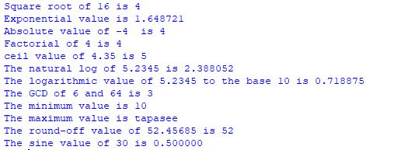

## 2)Python program to demonstrate data type conversions.

value=0x3a

value_in_int=int(value)

value_in_bin=bin(value)

value_in_oct=oct(value)

print("The values in int, binary, octal and hexadecimal are as follows")

#sep is used to separate individual values by a comma or space.

print(value_in_int, value_in_bin, value_in_oct, sep=",")



## 3)Python program to demonstrate evaluation of expression

## 

result=eval(input("Enter the expression : "))

#eval functions doesn’t accept string input.

print("Result is %f" %result)



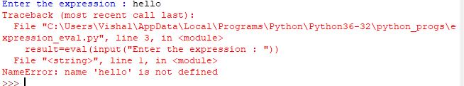

## 4)Python program to demonstrate variable declaration.

my_var1=5

print("Data type of my_var1 is ", type(my_var1))

my_var2="hello"

print("Data type of my_var1 is ", type(my_var2))

my_var3=25

my_var4=25

#id() is used to print the identity of an object (like memory address in C)

print("The identity of my_var3 is ", id(my_var3))

print("The identity of my_var4 is ", id(my_var4))

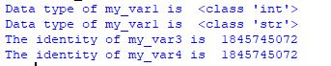

## **5)P**ython program to demonstrate formatted print

my_var=25

print(my_var +" is an integer")

#Concatenation operator accepts everything in string.

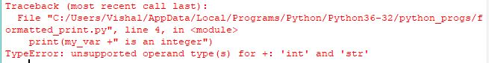

my_var=25

print(str(my_var) +" is an integer")



print("Welcome", end=" ")

print("to Python")



name="Linda"

print("Hello %20s" %name)



my_var1,my_var2,my_var3=1,2,3

print("1st variable={0}, 2nd variable={1}, 3rd variable={2}".format(my_var2, my_var3, my_var1))



## 6)Python program to calculate area of circle

## 

import math

radius=float(input("Enter the value of radius : "))

area=radius**2*math.pi

print("Area of circle is %f" %area)



**Conclusion :**

Various math operations can be performed by just importing math module, expressions can be simplified by using eval(), variables need not be declared explicitly.